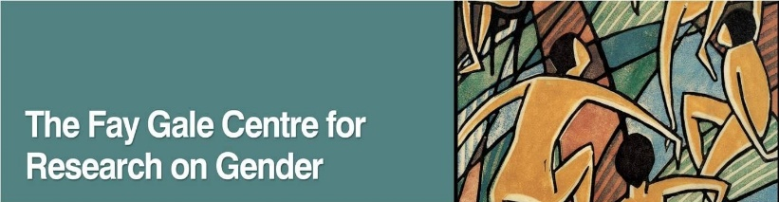

Emotions and Mental Health: Interdisciplinary Perspectives
Friday 29 November 2019
The University of Adelaide

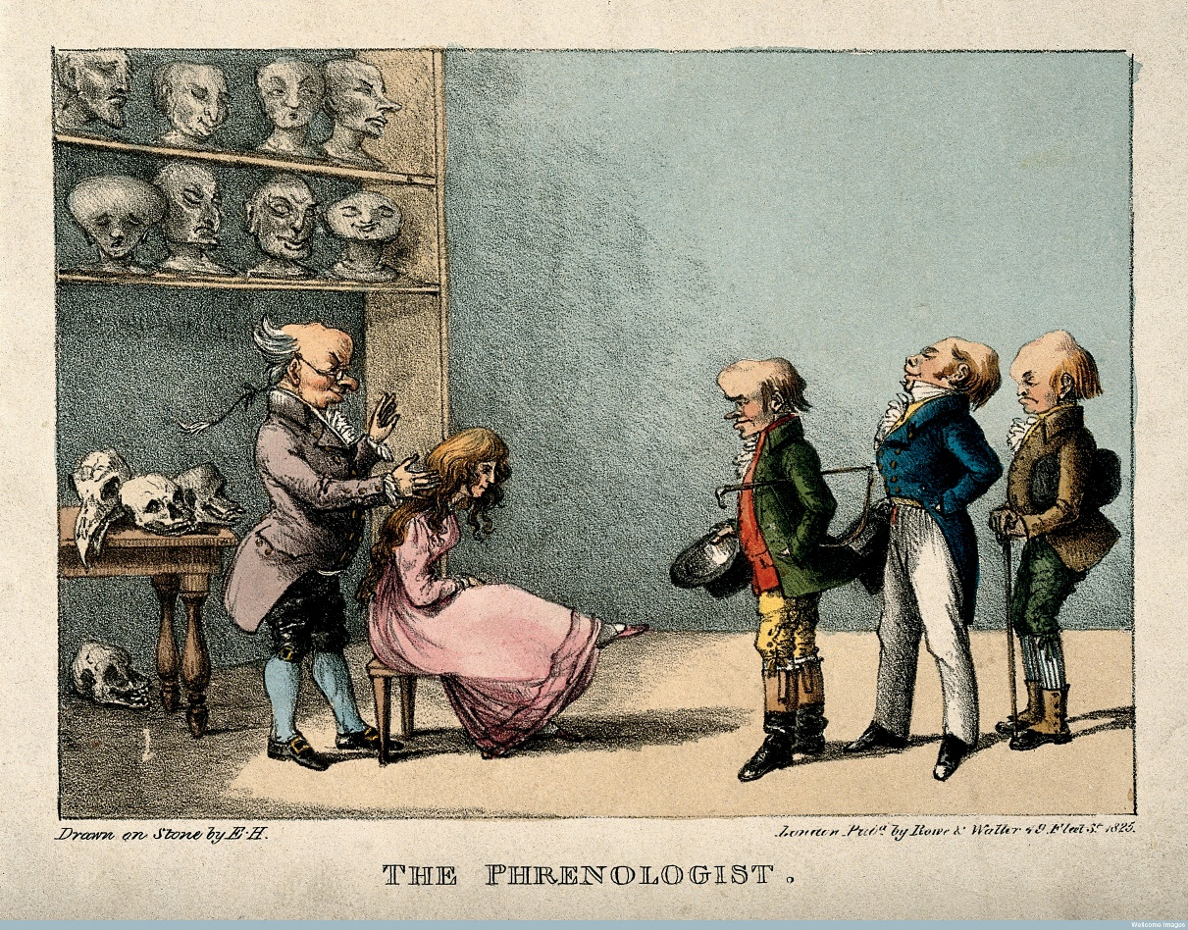

This ARC Centre of Excellence for the History of Emotions and Fay Gale Centre for Research on Gender workshop is on the theme of emotions and mental health. Doctors of madness, insanity and now mental health have long used the experience and expression of emotion as a gauge to psychological robustness. Our embodied experience of emotion is often critical to our own perception of wellbeing. Madness and mental illness are also emotive topics, being mobilised to encourage support and service provision, or to exclude those whose behaviour situates them beyond the ‘norm’. This symposium explores the relationship between emotion and mental health from an array of perspectives. All welcome.

Programme
Friday 29 November
Stretton Room (room 420), Napier Building, University of Adelaide
9-915 Arrive
915-930 Acknowledgement of country and welcome
930-1045 Keynote
Chair:
Emotions, Mental Wellbeing and the Mentally Afflicted in Early Modern Sweden and Finland
Riikka Miettinen
1045-1115 Tea and coffee
1115-1245 Session 1
Chair:
Maintaining Reason’s Boundary: Policing London’s Mad in the Long Eighteenth Century
Mark Neuendorf
Virtuous, Talented and Happy: Emotional Wellbeing in Nineteenth-Century Practical Phrenology
Lachlan McCarron
Mindfulness and the sanitisation of emotions in the workplace
Leanne Downing

1245-145 Lunch
145-315 Session 2
Chair:
Emotional bodies in the suicide narratives of Dante’s Divine Comedy
Emma Louise Barlow
Art with impact: using screen media to mobilise empathy for mental health
Fincina Hopgood

315-345 Tea and coffee
345-430 Closing discussion

Abstracts

Emotions, Mental Wellbeing and the Mentally Afflicted in Early Modern Sweden and Finland
Riikka Miettinen

As is well known, notions of mental health, sanity and insanity reveal a great deal about the emotional regimes, and emotional communities, of different times and cultures. Excessive, or lack of, emotions and expressions that breach the norms are associated with disturbances of the mind. The lines between apposite and incongruous emotions and their expressions are not always clear-cut but are nevertheless used in determining mental health. Moreover, mental health care relies heavily on altering and balancing emotions, be it by the remedies recommended in antiquity or the medication and therapies prescribed in the modern West. This paper discusses the interconnections between mental health and emotions in the early modern period, in particular in the context of early modern Swedish (and Finnish) communities. First, the focus is on understandings about the role of emotions (moods, passions etc.) in the holistic conceptions of health and as the symptoms or manifestations, and at times as triggers, of mental disorders. Embodied emotions, or their bodily experiences and expressions, were key signs of various illnesses such as melancholia, mania and furore. However, drawing the line between ‘sane’ and ‘insane’ emotions was at times challenging, as can be seen, for example, in court investigations over the mental health of criminal defendants and suicides. The paper also explores the ways in which these notions influenced the ‘lived experience of insanity’ – both at the individual and communal levels. Most importantly, care and healing practices included various kinds of emotion work. Certainly, experiences and expressions of a wide spectrum of emotions also very concretely shaped the everyday lives of those mentally afflicted. The primary material consists of a selection of lay health advice books, popular medical and spiritual treatises and descriptions in judicial records, letters and journals.

Dr Riikka Miettinen works as an Academy of Finland Postdoctoral Researcher at the Centre of Excellence in the History of Experiences, based at Tampere University, Finland. Between October and December 2019, she is a visiting researcher at the ARC Centre of Excellence for the History of Emotions at The University of Western Australia and The University of Adelaide. Her interests include the history of insanity, social history of medicine and the history of suicides, the disabled and poor relief, in particular in the contexts of early modern Sweden and Finland. Her research has been published in various refereed journals and edited books, and her recent publications include a monograph Suicide, Law, and Community in Early Modern Sweden (Palgrave Macmillan, 2019). She is currently working on a research project and monograph that focuses on the social history of the insane in early modern Sweden and is co-editing books and journals related to disability history and the history of insanity and emotions.

Emotional bodies in the suicide narratives of Dante’s Divine Comedy
Emma Louise Barlow

Suicide plays a dynamic role in both the narrative and structure of Dante’s Commedia, and yet the poet does not in fact mention the term ‘suicide’ anywhere in the work: Dido ‘slew herself for love’ (Inf. 5.61), Pier della Vigna describes suicide as a process in which ‘the ferocious soul deserts the body / after it has wrenched up its own roots’ (Inf. 13.94-94), and the anonymous Florentine suicide simply ‘made [his] house into [his] gallows’ (Inf. 13.151). It is thus unsurprising that the notion of mental health in connection with suicide is equally absent in explicit terms. Reading between the lines of Dante’s poetry, however, it becomes clear that the emotive language of the suicides within Dante’s oltremondo, and of Dante the pilgrim as he responds to their narratives, highlights a heterogeneous yet shared experience of loss and despair, mirroring contemporary understandings of mental health issues. Through an analysis of the emotive language associated with the narratives of Dante’s suicides, and the hybrid embodiment of the suicides inscribed in Dante’s text, this paper hopes to explore the ways in which, even inadvertently, Dante reflects on the distancing of the suicides from the civic bodies of their communities, from their own physical bodies, and from the vital rationality of their human minds, and thus to investigate the ways in which the lack of emotional wellbeing experienced by the suicides forces them to the edges of society’s, and their own, consciousness.

Emma Louise Barlow is a PhD candidate in Italian Studies at The University of Sydney, following from a BA (Languages) (Hons) also at USyd and an MSt in Modern Languages (Italian) at the University of Oxford. Her doctoral research proposes a study of Dante’s conception of suicide in his works, and of how these conceptions were shaped by Dante’s contemporary intellectual and literary landscape. She has presented her work at conferences in Australia, the UK, the USA and Italy. Her research interests include medieval and Renaissance Italian literature, palaeography, the history of emotions, and pedagogical practices in tertiary education.

Mindfulness and the sanitisation of emotions in the workplace
Leanne Downing

Over the past decade thousands of businesses around the globe have introduced mindfulness practices into their workplace cultures. From servicing large tech players such as Google, Facebook and Apple, through to public hospitals, universities, law firms and beyond, a profitable industry has been created around helping ‘stressed out’ and ‘disconnected’ workers better align with their emotions in the present moment.

As a traditionally Buddhist technique, what was once a tool for guided spiritual exploration is now being sold as a panacea for modern workplace attrition. This presentation explores what I see as an uneasy, and potentially negligent, adoption of mindfulness techniques as a one-size-fits-all commodity for workplace mental health.

Drawing on the work of Buddhist scholar Jon Kabat-Zinn, renowned sociologist George Ritzer, and the recent work of Terry Hyland, I will explore the ways in which mindfulness has been stripped of its ethical and spiritual moorings and commoditised as a commercial mental health tool – one that is often delivered without appropriate support for the emotional fall out that it can create.

Dr Leanne Downing is an Adjunct Senior Lecturer in the Department of Public Health at La Trobe University. She has a PhD in Media Studies and has held academic teaching and research positions at several institutions throughout Australia and New Zealand.

Art with impact: using screen media to mobilise empathy for mental health
Fincina Hopgood

As Richard Maltby has observed in relation to Hollywood films, cinema ‘relies for much of its aesthetic effect on its affective qualities, on the emotional engagement of its audience with the text.’ The capacity of film, TV and other forms of screen media to arouse the viewer’s emotions takes on further significance in relation to content dealing with mental health issues. Mental health organisations worldwide have drawn attention to the impact of media portrayals of mental illness and suicide, both on the emotional wellbeing of people with lived experience and the wider social discourse surrounding mental health. The potential of screen media’s emotional appeal to raise awareness of mental health issues, tackle stigma and build empathy for lived experience has been identified through my research collaborations with mental health organisations in Australia and internationally. As a case study, this paper will discuss the work of Art With Impact, a US-based non-profit organisation that harnesses the emotional power of film to pursue its mission of raising awareness of mental health by providing a platform for filmmakers with lived experience to tell their story.

Dr Fincina Hopgood is Lecturer in Screen Studies at the University of New England and a member of the UNE node for the ARC Centre of Excellence for the History of Emotions. Fincina’s research project Empathy and portrayals of mental illness in Australian visual culture was supported by CHE’s Associate Investigator scheme and her research has been published in the refereed journals Australasian Journal of Popular Culture (2019) and Adaptation (2016), and the edited collections American-Australian Cinema (2018) and Australian Screen in the 2000s (2017). Fincina is part of an interdisciplinary team with colleagues at Melbourne and La Trobe Universities working in collaboration with mental health organisations to investigate stigma, empathy and the positive potential of screen media for mental health.

Virtuous, Talented and Happy: Emotional Wellbeing in Nineteenth-Century Practical Phrenology
Lachlan McCarron

In the first half of the nineteenth century, the pseudo-science of phrenology grew to be a popular and influential way of understanding the mind. Phrenologists divided the brain into a number of innate faculties, and depicted emotion as part of an intricate system of checks and balances – for example, the natural tendency towards destructiveness, thought to be the source of anger, was counteracted by the brain’s inherent faculty of benevolence. This balance, however, could be disrupted by the extreme strength or deficiency of certain faculties, leading to mental illness. While the implications of these beliefs for the institutional treatment of mental illness have been well established, this paper will investigate the work of ‘practical’ phrenologists who emerged in the United States in the late 1830s. Where earlier phrenologists had written with a theoretical focus, practical phrenologists wrote guidance for self-improvement directed at a mass audience. This paper will therefore examine how practical phrenologists used the tenets of phrenology to promote personal responsibility for mental health. In doing so, it will draw connections between mental health, emotional wellbeing, notions of good character and the culture of self-improvement in nineteenth-century America.

Lachlan McCarron is an MPhil student in History at The University of Adelaide, with an interest in the intersection of emotion, society and politics in the nineteenth-century United States. His current research focuses on how phrenological understandings of emotion reflected and influenced the construction of race and gender in antebellum America.

‘Maintaining Reason’s Boundary: Policing London’s Mad in the Long Eighteenth Century’
Mark Neuendorf

In 1800, following an assassination attempt on George III by the millenarian James Hadfield, the British parliament passed successive Acts aimed at restricting the liberties of so-called ‘dangerous lunatics’, and providing for their incarceration. For historians of madness, this legislation heralded a new era of repression, sharpening attitudes towards those deemed to be unsound of mind, and prompting the development of new social, legal and disciplinary apparatuses to classify and secure them. Yet, by the early modern period, madness already loomed large in depictions of public disorder, emerging in the eighteenth century as an object of outright surveillance in England’s metropolis. Through a process of ‘deviance amplification’ the London mad were rendered, in Ann Jessie van Sant’s words, obnoxiously visible: an unseemly presence in a consciously polite city. This paper documents the evolution of this collective anxiety from the seventeenth century, demonstrating how the development of commercial London imposed new cultural and spatial boundaries on the mentally ill. Moreover, it shows that concerns about insanity were cultivated by leading ‘law and order’ figures through press reporting, creating a moral panic which – coupled with the establishment of an organised police force in the city – hastened the sequestration of mad-people from public spaces. Ultimately, these developments formed the preconditions for the later lunacy Acts, and the paper will conclude with a brief discussion of their wider political legacies.

Mark Neuendorf is a Visiting Research Fellow at The University of Adelaide. His research examines the intersection of emotions and psychiatry, with a particular focus on the emergence of organised psychiatric reform. His research has been published in Medical History, and a monograph, Emotions and the Making of Psychiatric Reform in Britain, 1770-1820, is forthcoming with Palgrave Macmillan.

